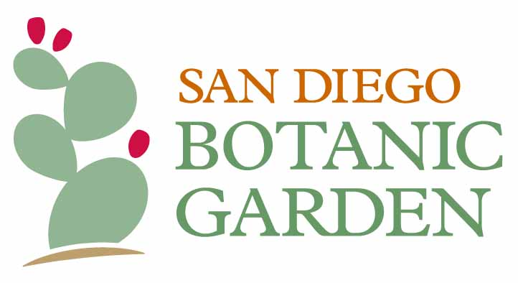

**PRESS RELEASE**

**April 21, 2021**

**For Immediate Release**

**For more information, contact:**

Organization: San Diego Botanic Garden

Contact: Ashley Grable

Title: Communications and External Relations Manager

Phone: 760-688-8350

E-mail: [agrable@sdbgarden.org](mailto:agrable@sdbgarden.org)

County of San Diego to proclaim Saturday, April 24 as “San Diego Botanic Garden Day” in recognition of Garden’s environmental stewardship

Encinitas, California – The County of San Diego will honor San Diego Botanic Garden (SDBG) on Saturday, April 24, for “outstanding service, leadership, and commitment to environmental stewardship” by celebrating “San Diego Botanic Garden Day” throughout the County. Supervisor Terra Lawson-Remer will mark the occasion at 8:00 AM that day with a proclamation at the Garden approved by the County Board of Supervisors.

Among its recent achievements, SDBG’s world class plant conservation and education programs restored 15 acres of natural area bordering Encinitas’s Cottonwood Creek Park (more information available [here](https://www.sdbgarden.org/quail-tracks-2/QT-vol31-4-2.htm)); carried out 165 wild plant collections in San Diego County; educated over 1,000 local students through field trips and formal classroom support targeting underserved schools; collected more than 20,000 seeds from native endangered species for long-term conservation in seed banks; and supported genetic sequencing of nine of the 11 species in the ocotillo family, desert plant plants native to southern California and the surrounding region.

The County of San Diego reserves this honor to recognize organizations dedicated to the best ideals of public service. SDBG was also recently named the 2020 winner of the City of Encinitas Environmental Commission’s prestigious Environmental Award Program (EAP).

***About San Diego Botanic Garden***

Established in 1970, San Diego Botanic Garden (SDBG) is a 37-acre garden that inspires people of all ages to connect with plants and nature. The Garden’s four miles of trails showcase 5,000 plant species and varieties, including 300 plants for which SDBG is the only garden maintaining a population. SDBG has 15 gardens representing different regions of the world, 12 demonstration gardens, and the largest public bamboo collection in North America. SDBG has three children’s gardens, including its flagship, one-acre Hamilton Children’s Garden, the largest kids’ garden on the west coast.

The main entrance to the Garden is located at 300 Quail Gardens Drive, Encinitas, CA, 92024. SDBG currently requires all visitors (both members and non-members) to reserve an entry time online before arriving at the Garden. All visitors ages 2+ must wear a face covering and maintain a distance of at least 6 feet from visitors of other households.

**###**