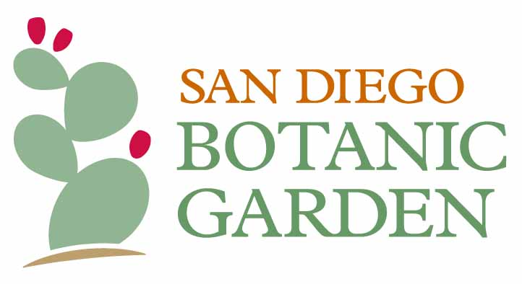
230 Quail Gardens Drive, Encinitas, CA 92024
760/436-3036 SDBGarden.org

March 23, 2021

For Immediate Release
San Diego Botanic Garden wins Environmental Award

San Diego Botanic Garden (SDBG) is honored to be named a 2020 winner of the City of Encinitas Environmental Commission’s prestigious Environmental Award Program (EAP). The City of Encinitas recognized SDBG for its Excellence in Environmental Stewardship among non-profit organizations, noting that the Garden is “the preeminent plant conservation institute in the region, and one of the most important botanic gardens in the country.”

Among its many achievements in 2020, SDBG’s world class plant conservation and education programs restored 15 acres of natural area bordering Encinitas’s Cottonwood Creek Park (more information available here); carried out 165 wild plant collections in San Diego County; educated over 1,000 local students through field trips and formal classroom support targeting underserved schools; collected more than 20,000 seeds from native endangered species for long-term conservation in seed banks; and supported genetic sequencing of nine of the 11 species in the ocotillo family, desert plant plants native to southern California and the surrounding region.

“We couldn’t be prouder of receiving the Encinitas Environmental Award,” said SDBG President and CEO, Ari Novy, PhD. “San Diego Botanic Garden is proud of work we do every day to steward the environment, save plants, and educate everyone about the wonders of nature.”

The Garden will receive its award at the Encinitas City Council meeting on Wednesday, April 14, in honor of Earth Day, April 22. The Environmental Commission established the EAP in 2015 to recognize deserving individuals, businesses, and non-profits for their commitment to environmental stewardship and outstanding environmental achievements.

About San Diego Botanic Garden
Established in 1970, San Diego Botanic Garden (SDBG), is a 37-acre garden that inspires people of all ages to connect with plants and nature. The Garden’s four miles of trails showcase 5,000 plant species and varieties, including 300 plants for which SDBG is the only garden maintaining a population. SDBG has 15 gardens representing different regions of the world, 12 demonstration gardens — including two edible gardens — and the largest public bamboo collection in North America. SDBG has three children’s gardens, including its flagship, one-acre Hamilton Children’s Garden, the largest children’s garden on the west coast.

The main entrance to the Garden is the Dickinson Family Education Conservatory, located at 300 Quail Gardens Drive, Encinitas, CA, 92024. SDBG currently requires all visitors (both members and non-members) to reserve an entry time online before arriving at the Garden. Everyone ages 2+ must wear a face covering and maintain a distance of at least 6' from visitors of other households. For more information and to reserve tickets, visit https://www.sdbgarden.org/visitor-guidelines.htm.

