FOR IMMEDIATE RELEASE
IMAGES FOR PRESS

San Diego Botanic Garden’s Rare Corpse Flower Blooms on Halloween Night
Only a few of these unusual Indonesian flowers bloom each year at gardens across the world, and SDBG is the only known garden in San Diego that grows this exotic species

Encinitas, Calif. - (October 31, 2021) - The San Diego Botanic Garden (SDBG), a 37-acre urban oasis in north San Diego County, this afternoon announced its rare corpse flower is now in coming into full bloom on Halloween night. This flower only blooms every four or five years, and the fully opened bloom lasts just for 48 hours before it fades. The corpse flower plant is named after its foul-smelling scent, which fanatics have deemed the ‘smell of death.’
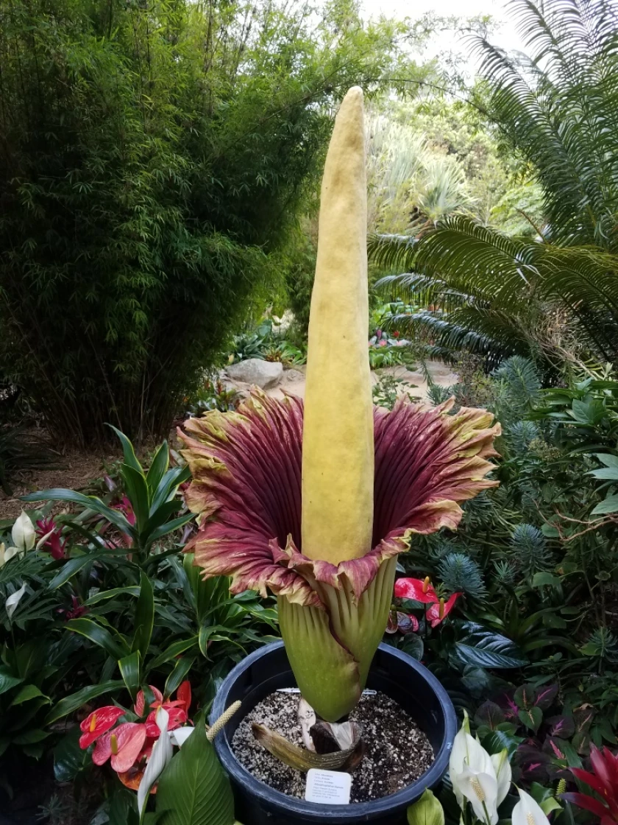

"The corpse flower is the rock star of the plant world,” said SDBG president and CEO, Ari Novy. “It is taking center stage today with its incredible bloom and stench. We couldn’t be more excited for everyone to come see this amazing plant in its full glory, but hurry up! It’s a short show."

The corpse flower, also known as Amorphophallus titanum, is endemic to the rainforests of Sumatra, Indonesia. The actual flowers of the plant are not the impressive, feet-tall struction now on display, but small flowers housed inside the base of the bloom spike’s outer casing. Both male and female flowers grow on the same bloom spike. The female flowers open first, and then, a day or two afterward, the male flowers open. The timing prevents the plant from self-pollinating. The corpse flower is an endangered plant with fewer than 1,000 plants remaining in the wild.

The garden will be open for visitors to view the rare corpse flower plant from 9 am to 9 pm today and tomorrow. To purchase tickets or for additional information, please visit: https://sdbgarden.org/corpse-plant.htm. For those who cannot make the in-person event, a livestream of the bloom’s development is available on the same page.

For press inquiries, please contact Ashley Grable at 760-688-8350 or agrable@sdbgarden.org.

###

San Diego Botanic Garden
Established in 1970, San Diego Botanic Garden (SDBG) is a 37-acre urban oasis located in Encinitas, California, just north of San Diego. We garden to create, share and apply plant wisdom in our world. The Garden’s four miles of trails display more than 5,000 plant species and varieties, including 300 plants for which SDBG is the only garden maintaining a population. SDBG has 15 gardens that represent different regions of the world, 12 demonstration gardens, and the largest public bamboo collection in North America. SDBG has three children’s gardens, including its flagship, one-acre Hamilton Children’s Garden, the largest kids’ garden on the west coast.

