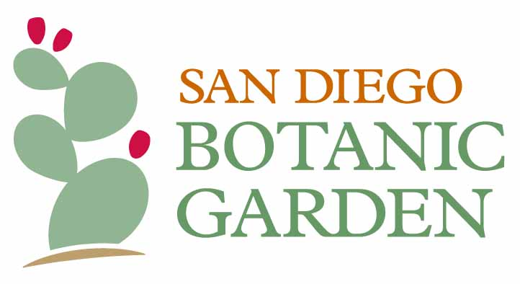
FOR IMMEDIATE RELEASE
IMAGES FOR PRESS

For more information, contact:
Sonja Farra at sonja@imwagency.com / 714-222-5802
Ashley Grable at agrable@sdbgarden.org / 760-688-8350

New Augmented Reality Exhibition ‘Seeing the Invisible’ to Premiere at
San Diego Botanic Garden September 24
Featuring AR Works by international artists and premiering simultaneously across the globe

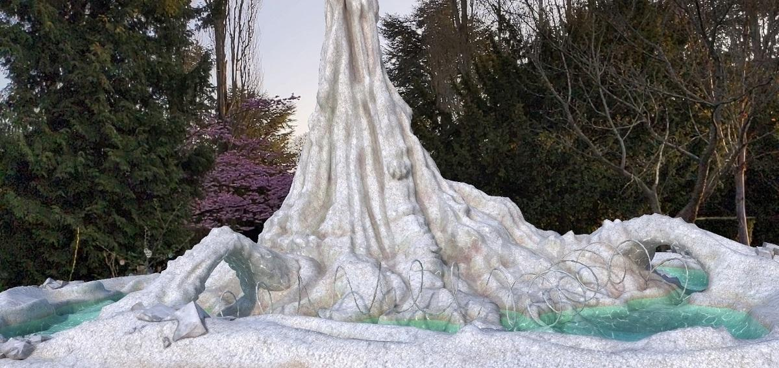
Detail image of Sigalit Landau, Salt Stalagmite #1 [Three Bridges], 2021

Encinitas, Calif. - (September 9, 2021) - The most ambitious and expansive exhibition to date of contemporary artworks created with augmented reality (AR) technology will premiere across 12 gardens in six countries simultaneously in September 2021, including the San Diego Botanic Garden (SDBG).

Seeing the Invisible features works by a dozen international artists such as Ai Weiwei, Refik Anadol, El Anatsui, Mohammed Kazem, Sigalit Landau, Sarah Meyohas, Pamela Rosenkranz, and Timur Si-Qin—including several artists’ first work in AR. Forging new links between botanical gardens located in diverse biomes around the globe, the exhibition fosters collaboration between institutions, artists, and audiences, highlighting the power of art to connect people around the world.

“This exhibition allows artists who have not previously worked in AR to expand on ideas that are central to their practice in entirely new ways,” said Seeing the Invisible Co-Curator Hadas Maor. “In doing so, the exhibition engages a wide range of visitors with contemporary artworks, including a number that address critical issues around the environment, through this exciting new medium.”

The first exhibition of its kind to be developed as a collaboration among botanical gardens around the world. Seeing the Invisible will place the same exhibition of commissioned artworks in analogous sites in 12 outdoor garden settings located in different biomes all around the world, creating parallels and contrasts between them. For example, the same work might be set within a group of coastal prickly pear cacti in San Diego and among a lush forest of giant redwoods in Edinburgh. The AR nature of the exhibition allows for the creation of expansive, immersive works that engage with existing features of the natural landscape beyond the limitations of what is possible with physical artworks. Many of the works created for the exhibition will address related themes around nature, environment, sustainability, and explore the interplay of the physical world with the digital one.

“Coming out of the pandemic when outdoor experiences and nature have taken on a new meaning and gravity in our lives, this exhibition represents a fresh way for people to engage with art and nature simultaneously,” added Seeing the Invisible Co-Curator Tal Michael Haring. “The interplay of these augmented reality works in vibrant natural settings breaks down the binary between what is often considered ‘natural’ versus ‘digital’, and in this way provides an exhibition experience that is much more connected to the way we live today.”

“Seeing the Invisible was born out of a collaboration during the pandemic with the Jerusalem Botanical Gardens that opened our eyes to the incredible opportunities for creating an entirely new kind of contemporary art experience within the setting of a botanical garden,” said Outset Contemporary Art Fund Co-Founder Candida Gertler OBE and Outset Contemporary Art Fund Israel Director Mirav Katri. “We are thrilled to be partnering with exceptional gardens from all across the world on this exhibition bridging the physical and digital worlds to create a new phygital model, bringing their expert knowledge of their field together with the most cutting-edge technology in contemporary art to develop a new exhibition format beyond the typical museum or gallery space.”

Anticipating the opening of the global exhibit, SDBG President and CEO, Dr. Ari Novy, shared, "Botanic gardens are wonderful places to leverage art to explore our relationship with nature. San Diego Botanic Garden is thrilled to present Seeing the Invisible, a completely new kind of contemporary art experience, in partnership with outstanding artists and gardens from around the world."

Visitors will engage with Seeing the Invisible via an app designed for the exhibition downloadable to smartphones and tablets, which will be available for iPhone and Android in the App Store and Google Play in the coming weeks.

This project has been made possible in partnership with The Jerusalem Foundation. Support for San Diego Botanic Garden’s presentation of Seeing the Invisible is provided In honor of Frances Hamilton White, as well as by Randi and Marissa Coopersmith, Leichtag Foundation, Carol and Martin Dickinson, The Robinson Family, Marcia and Dick Brockett, and an anonymous Trustee.
Seeing the Invisible is co-curated by Hadas Maor and Tal Michael Haring, and organized by Jerusalem Botanical Gardens and Outset Contemporary Art Fund.

To book entry to SDBG and for additional information, please visit: www.sdbgarden.org/Invisible.htm and www.seeingtheinvisible.art.com. Entrance to World of Bromeliads is included with the price of admission. Members receive free admission. Non-member admissions range from $10 to $18. SDBG provides free entry to members of other gardens participating in the American Horticultural Society's Reciprocal Admissions Program.

###

San Diego Botanic Garden
Established in 1970, San Diego Botanic Garden is a 37-acre urban oasis that creates, shares and applies plant wisdom with people of all backgrounds, ages and interests. The Garden’s four miles of trails display more than 5,000 plant species and varieties, including 300 plants for which SDBG is the only garden maintaining a population. SDBG has 15 gardens that represent different regions of the world, 12 demonstration gardens, and the largest public bamboo collection in North America. SDBG has three children’s gardens, including its flagship, one-acre Hamilton Children’s Garden, the largest kids’ garden on the west coast.

