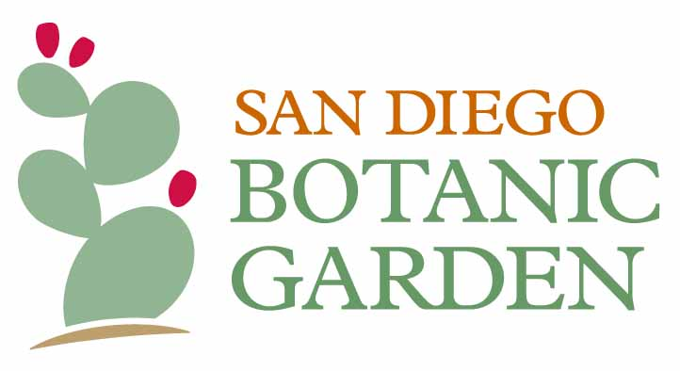
PRESS RELEASE

March 29, 2021
For Immediate Release

For more information, contact:
Organization: San Diego Botanic Garden
Contact: Ashley Grable
Title: Communications and External Relations Manager
Phone: 760-688-8350
E-mail: agrable@sdbgarden.org
San Diego Botanic Garden opens month-long World of Orchids show this weekend

Exhibit
Wednesdays through Sundays, April 3 – May 2
10 am – 5 pm, select days until 8pm

Orchid marketplace
Select Fridays and ALL Saturdays and Sundays, April 3 – May 2
10 am – 4:30 pm

Encinitas, California – San Diego Botanic Garden (SDBG) will host its first annual spring orchid showcase, World of Orchids, from Saturday, April 3 through Sunday, May 2. The exhibit, which kicks off Easter weekend, will be staged in the Garden’s state-of-the-art, 8,000 square foot, glass-enclosed facility – the Dickinson Family Education Conservatory – which opened last year as a $6.5 million addition to the lush, 37-acre urban oasis.

“The orchids at San Diego Botanic Garden have beauty and grace that will knock your socks off,” said SDBG President and CEO, Ari Novy, PhD. “There’s nothing better than a bright spring day among the orchids.”

SDBG’s highly awarded Artist-in-Residence, René van Rems, AIFD, will serve as Creative Director for the exhibit. Van Rems will design a new display for each of the five weeks, allowing visitors to experience changing flowers and arrangements across multiple visits. Van Rems says that his passion “is to enhance through design what nature provides.” His displays at the World of Orchids exhibit will “inspire people to look at plants, botanical elements and their environment with renewed awareness.”
The stunning designs will feature impressive specimens, locally-bred hybrids, and rare species plants displayed in unique and unexpected ways. In addition to the many orchids that typically grow in the Garden’s conservatory, displays will include plants on loan from private growers belonging to two local groups – the San Diego County Orchid Society (SDCOS, https://www.sdorchids.com) and the Palomar Orchid Society (http://www.palomarorchid.org) – as well as orchids and materials from local businesses including Cal Pacific Orchid Farm, Divine Orchids, Dos Gringos, Mellano & Company, Rene van Rems Intl., and Lumbercycle.

On Saturdays and Sundays, as well as select Fridays during the month, vendors and conservation organizations will offer unusual and unique orchids and merchandise for sale. Admission to World of Orchids is included with the purchase of a one-day ticket or an annual membership. For more information and to reserve an entrance date and time, visit https://www.sdbgarden.org/orchids.htm.

About San Diego Botanic Garden
Established in 1970, San Diego Botanic Garden (SDBG) is a 37-acre garden that inspires people of all ages to connect with plants and nature. The Garden’s four miles of trails showcase 5,000 plant species and varieties, including 300 plants for which SDBG is the only garden maintaining a population. SDBG has 15 gardens representing different regions of the world, 12 demonstration gardens and the largest public bamboo collection in North America. SDBG has three children’s gardens, including its flagship, one-acre Hamilton Children’s Garden, the largest kids’ garden on the west coast.

The main entrance to the Garden is located at 300 Quail Gardens Drive, Encinitas, CA, 92024. SDBG currently requires all visitors (both members and non-members) to reserve an entry time online before arriving at the Garden. All visitors ages 2+ must wear a face covering and maintain a distance of at least 6 feet from visitors of other households.

###

